While they are in IE have them right click within the screen of the course that is not launching and go to "inspect element” This will then show what browser that they are reverting to. (example in screenshot below)
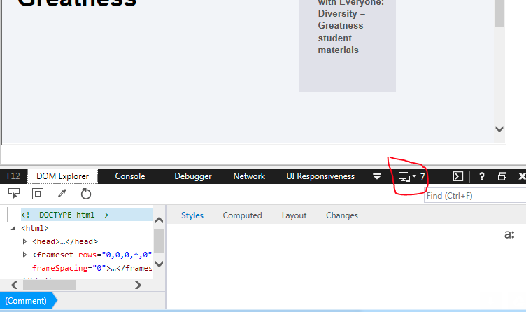

Here is some information they can pass along to their IT team to help resolve the issue globally.

While we do set the "X-UA-compatible" header, we set it to "Edge" which is the latest version of IE.

This setting can also be managed using IE Enterprise Mode. This is probably what is happening here.

https://technet.microsoft.com/en-us/itpro/internet-explorer/ie11-deploy-guide/fix-compat-issues-with-doc-modes-and-enterprise-mode-site-list

